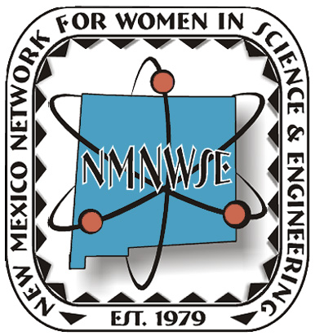 | IMPACT!  The NM Network for Women in  Science and Engineering Award  2013 Nomination Form |   NM Commission on the Status of Women  Information and Instructions  Eligible candidates must be:  - over 21 years of age and  - currently living in New Mexico  Previous award recipients are ineligible for consideration. NMNWSE Board members, Commission staff and Commissioners are only eligible after six months from their final date of service. Please email the IMPACT! Chair or call the NMNWSE Communications Chair to verify Award recipients.  Submission Requirements  Please submit the following information:  - One complete packet of information to include nomination form, summary and supportive materials.  - 500-word summary that summarizes the nominee’s specific achievements, the impact of her contributions to the goals of the Network and a brief statement on why she deserves the Award.  - Supporting materials: These materials should justify consideration of the nominee and should include three or more letters of recommendation. Supporting materials should emphasize the candidate's peer mentoring (outreach within the career / job arena), community involvement (outreach outside of career/job arena), and outreach to minorities. They may also include biographical data emphasizing leadership or community roles with quantifiable results that support the goals of the Network, commitments, mentorship, volunteer and compensated advocacy work, and other supporting materials such as newspaper or magazine articles. Please limit supporting materials to six (6) pages.  - All documents should be produced on 8.5” x 11” paper, using 12 point font. Larger documents should be reduced.  - All documents should be saved as a word document or a pdf using the applicant’s last name and first initial: LastName_FirstInitial.  - Provide one photograph (3” x 4” or 4” x 6”, color or black and white, preferable electronically) for use in publicity  - Submit a $10 nomination fee payable to NMNWSE. PO Box 1360, Los Alamos, NM 87544. Please request a receipt for your records.  NOTE:  - Letters of recommendation can come from mentors, employers, teachers, leaders, and/or friends. Three letters are strongly recommended but not required.  - Nomination packets containing MORE than six (6) pages of supporting documents may be edited by the Network and/or Commission staff.  2013 NOMINATION DEADLINE: extended to Sep 9, 2013
E-mail your nomination packet to:  Jennie DeMarco, NMNWSE Impact! Award Chair  jennied@nmsu.edu  or mail a hardcopy to:  IMPACT! Chair c/o NMNWSE, PO box 1360, Los Alamos, NM 87544  Questions?  Email Jennie or contact the NMNWSE Communications Chair  Tinka Gammel at 505-690-1318 or webmaster@nmnmwse.org | The New Mexico Network for Women in Science and Engineering began in 1975 with a core group of faculty and staff from UNM wanting to reach out to women in science as a group. Incorporated in 1979, the Network works to encourage and help women enter and succeed in Science, Technology, Engineering and Math (STEM) careers and promote networking and communication among members by providing regularly scheduled meetings, talks and other local activities. About 1000 teens each year attend our technical career workshops. Our Annual Meeting and Technical Symposium provides members an opportunity to present technical papers in a supportive environment as well as professional development and networking opportunities. | In 1974, the NM Commission on the Status of Women was created by state statute to increase the knowledge of the rights, responsibilities and interests of women and girls in New Mexico and to preserve women’s history and contributions to our state. The office is charged with conducting statewide studies on the status of women, acting as a clearinghouse and referral service on issues impacting women, recommending methods to overcome discrimination against women, promoting methods for women to develop their skills and continue their education, hosting periodic statewide conferences for women, collaborating with other entities working with women and securing recognition for women’s accomplishments and contributions to New Mexico.
The New Mexico Network for Women in Science and Engineering, in cooperation with the NM Commission on the Status of Women, initiated in 2007 the NMNWSE IMPACT! Award to recognize the contributions of women in New Mexico. This fall, the 7th Annual IMPACT! Award will be presented to a New Mexico woman for her extraordinary efforts in furthering the goals of the Network. These goals include encouraging and helping women enter and succeed in Science, Technology, Engineering and Math (STEM) and related nontraditional careers and promoting networking and communication among women in these careers. The honoree will be recognized during the NMNWSE Annual Meeting and Technical Symposium, which will be held October 25-27, 2013 in Mountainair, NM.
NOMINEE: _______________________________________________________________________________________
ADDRESS: _________________________________________________________________________________________
CITY: ___________________________________________________________ ZIP: ______________________________
PHONE: ______________________________________ EMAIL: ________________________________________________
NOMINATOR: ____________________________________________________________________________________
AFFILIATION WITH NOMINEE: _____________________________________________________________________________
ADDRESS: _________________________________________________________________________________________
CITY: ___________________________________________________________ ZIP: ______________________________
PHONE: ______________________________________ EMAIL: ________________________________________________

